## Front End Engineering-II /Artificial

## Intelligence and Machine Learning

Project Report

Semester-IV (Batch-2022)

Parking Spot Detection and Counting in

Video Feed using OpenCV



**Supervised By: Submitted By:**

Ms. Shagun Sharma

Jiya: 2210990463(G10)

Kartik Bhardwaj: 2210990487(G10)

Kartik Grover: 2210990488(G10)

**Department of Computer Science and Engineering**

## Chitkara University Institute of Engineering & Technology,

## Chitkara University, Punjab

**ABSTRACT**

**BRIEF OVERVIEW OF OUR PROJECT:**

* This project aims to detect and count parking spots in real-time from a video feed using OpenCV.
* The objective is to optimize parking space utilization through automated monitoring.
* Methodology involves preprocessing video frames using techniques such as gray scaling, Gaussian blurring, adaptive thresholding, median blurring, and dilation.
* Parking spot positions are pre-defined and loaded from a stored file.
* The algorithm iteratively processes each frame, detecting and marking parking spots based on occupancy status.
* Results demonstrate the effectiveness of the solution in accurately identifying parking spots and providing real-time occupancy information.
* The project contributes to computer vision applications for smart parking systems, benefiting urban planning and transportation management.
* The project utilizes Python libraries such as cv2, cvzone, and NumPy for implementation.
* Real-time processing enables immediate feedback on parking spot occupancy, aiding in decision-making for drivers and parking management.
* The solution offers potential applications in smart cities, reducing traffic congestion and carbon emissions by optimizing parking utilisation.

**TABLE OF CONTENT**

* INTRODUCTION
* PROBLEM DEFINITION AND REQUIREMENTS
* PROPOSED DESIGN/METHODOLOGY
* RESULTS
* REFERENCES

**INTRODUCTION**

**Background:**

* **Urbanization Challenges**: Rapid urbanization has led to an increased concentration of population in cities, exacerbating issues such as traffic congestion, air pollution, and limited parking availability.
* **Manual Monitoring Limitations**: Traditional parking management relies heavily on manual methods, where parking attendants manually monitor parking spaces, which is time-consuming, labour-intensive, and prone to errors.
* **Need for Automation**: With the rise of smart city initiatives and advancements in technology, there is a growing need for automated parking management systems that can optimize parking space utilization, improve traffic flow, and enhance the overall urban experience.
* **Parking Demand vs Supply Discrepancy:** The discrepancy between parking demand and supply is a common challenge in urban areas, where the number of vehicles far exceeds the available parking spaces. This imbalance lead to overcrowded parking’s lots, illegal parking, increased traffic congestion as drivers circle in search of parking.

**Objectives:**

**Real-time Detection System**: Develop a robust system capable of detecting parking spots in real-time from a video feed, allowing for immediate response to changes in parking availability.

**Computer Vision Techniques**: Utilize computer vision techniques, particularly leveraging the capabilities of OpenCV and related libraries, to analyse video frames, identify parking spots, and determine their occupancy status.

**Enhanced Spot Visibility:** Implement preprocessing steps such as image enhancement, noise reduction, and feature extraction to improve the visibility and accuracy of detected parking spots.

**Data Management:** Design efficient data storage and retrieval mechanisms to maintain the state of parking spots across multiple video frames, ensuring continuity and reliability in the detection process.

**Accuracy Improvement**: Enhance the accuracy of parking spot detection algorithms by implementing advanced image processing techniques, such as deep learning-based object detection models or feature-based matching algorithms, to handle diverse parking lot layouts and environmental conditions.

**Dynamic Parking Management**: Develop algorithms to dynamically adjust parking space allocations based on real-time demand, traffic flow patterns, and special events. This could involve implementing predictive analytics models to forecast parking demand and optimize space utilization in anticipation of peak periods.

**Significance:**

**Transformative Impact**: The development of a real-time parking spot detection and counting system has the potential to revolutionize parking management practices, offering a more efficient and scalable solution compared to traditional manual methods.

**Driver Convenience**: By providing real-time information on available parking spaces, the system can significantly reduce the time and frustration associated with searching for parking, improving the overall experience for drivers.

**Data-Driven Decision Making**: Parking operators and urban planners can leverage the insights provided by the system to make informed decisions regarding parking space allocation, pricing strategies, and infrastructure investments, leading to more effective and equitable parking management.

**Urban Mobility and Sustainability**: Optimizing parking space utilization can contribute to alleviating traffic congestion, reducing carbon emissions, and promoting sustainable urban mobility patterns, aligning with broader efforts to create liveable, environmentally-friendly cities.

**Smart City Integration**: The system can serve as a foundational component of smart city initiatives, facilitating the development of integrated transportation systems and fostering innovation in urban planning and management.

**PROBLEM**

The problem at hand involves the inefficient utilization of parking space in urban areas, leading to congestion, frustration among drivers, and economic losses. Traditional parking management systems are manual, prone to errors, and lack real-time monitoring capabilities, exacerbating the problem. Therefore, there is a need for an automated solution that can accurately detect parking spots, monitor their occupancy status in real-time, and provide actionable insights to optimize parking space utilization.

**REQUIREMENTS**

* **Real-Time Detection**: The system should be capable of detecting parking spots and monitoring their occupancy status in real-time from a video feed.
* **Accuracy:** The detection algorithm should have high accuracy in identifying parking spots and distinguishing between vacant and occupied spaces, even under varying lighting conditions and environmental factors.
* **Scalability**: The system should be scalable to handle parking lots of varying sizes and configurations, from small lots to large multi-level parking structures.
* **Robustness**: It should be robust against occlusions, shadows, reflections, and other common challenges encountered in parking environments.
* **Integration**: The system should seamlessly integrate with existing parking infrastructure, including cameras, sensors, and management software, to facilitate easy deployment and interoperability.
* **User** **Interface**: A user-friendly interface should be provided for parking operators and administrators to monitor parking spot status, view occupancy statistics, and configure system settings.
* **Alerting** **Mechanism**: The system should have an alerting mechanism to notify parking operators and drivers of any anomalies or emergencies, such as unauthorized parking, vehicle theft, or safety hazards.
* **Data** **Privacy**: Ensure compliance with data privacy regulations and standards by implementing measures to protect the privacy and security of sensitive information collected by the system.
* **Maintenance** **and** **Support**: Provide ongoing maintenance, updates, and technical support to ensure the system's reliability, performance, and longevity.
* **Cost**-**Effectiveness**: The solution should be cost-effective to implement and maintain, offering a favourable return on investment for parking operators and stakeholders.

By meeting these requirements, the proposed system aims to address the challenges of parking management effectively, improve urban mobility, and enhance the overall parking experience for drivers and stakeholders.

**PROPOSED DESIGN/METHODOLOGY**

* **Schematic Diagram**: The system architecture can be represented by a schematic diagram illustrating the components and their interactions. This includes modules for video input, preprocessing, parking spot detection, occupancy monitoring, user interface, and data storage.
* **File Structure**: The file structure of the project should be organized logically, with directories for source code, datasets, documentation, and dependencies.
* **Algorithms Used:**
* **Image Preprocessing**: Techniques such as grayscale conversion, Gaussian blurring, adaptive thresholding, and morphological operations have been employed to enhance image quality and reduce noise.
* **Object Detection**: Algorithms have been used for detecting parking spots within the pre-processed images.
* **Occupancy Monitoring**: Once parking spots are detected, algorithms can track vehicle presence over time using techniques such as background subtraction, motion detection, or object tracking.
* **Data Storage and Retrieval**: Structured data storage formats like CSV have been used to store information about parking spot locations, occupancy status, timestamps, and any associated metadata.
* **Integration with Existing Infrastructure:** The system should integrate seamlessly with existing parking infrastructure, such as CCTV cameras or sensor networks.
* **User Interface**: A graphical user interface (GUI) can be designed to visualize parking spot detections, display occupancy statistics, and provide controls for system configuration.
* **Maintenance and Updates**: Automated update mechanisms and remote monitoring tools can be implemented to ensure the system remains operational and up-to-date. Version control systems like Git can be used to manage codebase changes, track issues, and collaborate with team members.
* **Testing and Validation**: Thorough testing and validation procedures should be implemented to verify the functionality, performance, and reliability of the system. This may include unit testing, integration testing, stress testing, and real-world field trials to evaluate the system under diverse conditions.

**RESULTS**

Fig 1: Car Parking Image

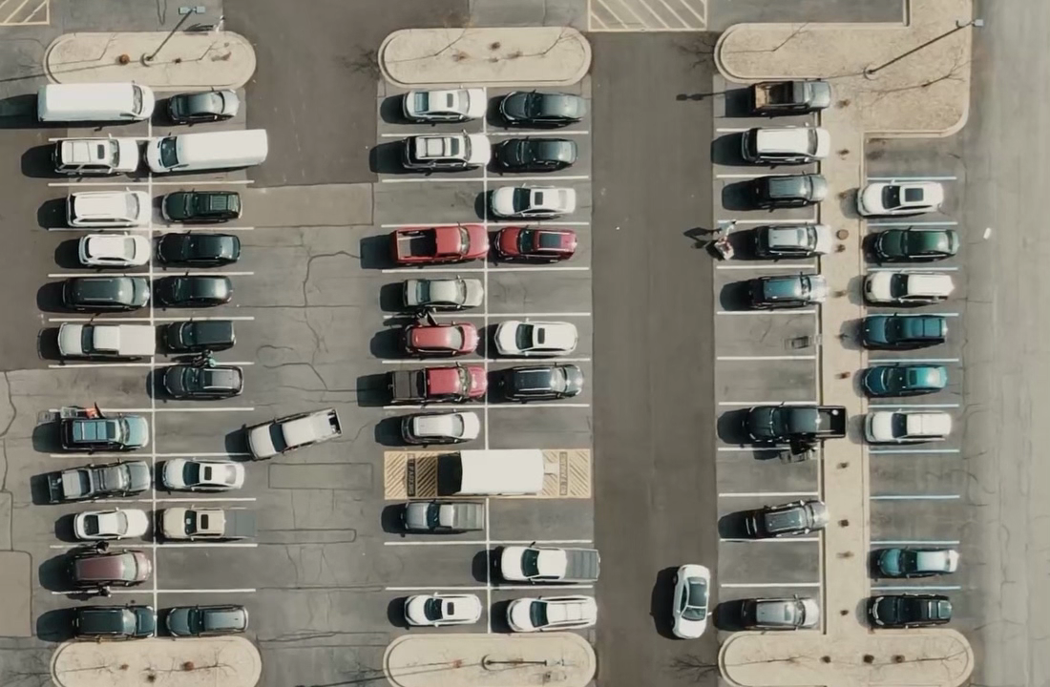

Fig 2: making rectangle on image using function ‘mouseclick’

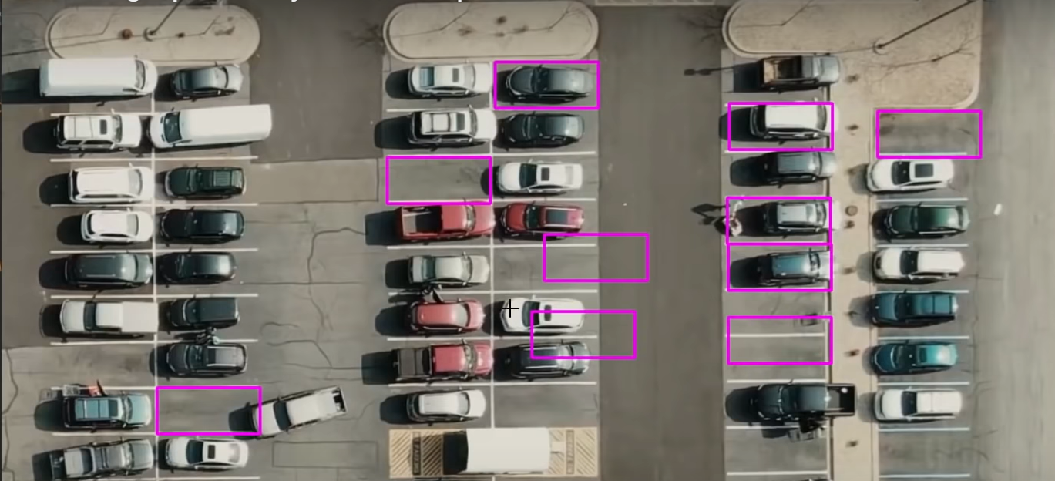

Fig 3: loading parking space positions

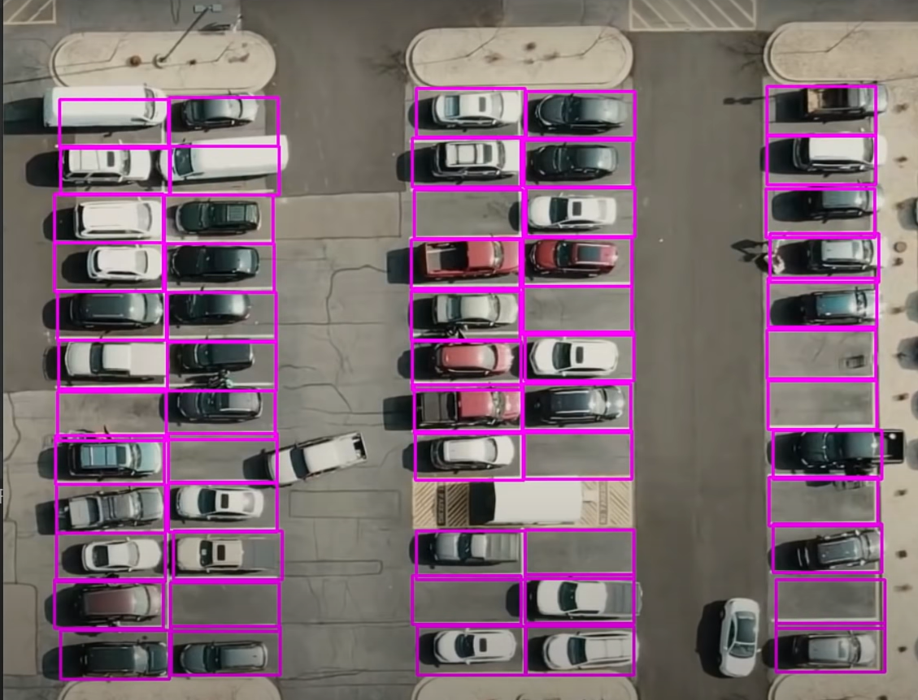

Fig 4:converting image to grayscale

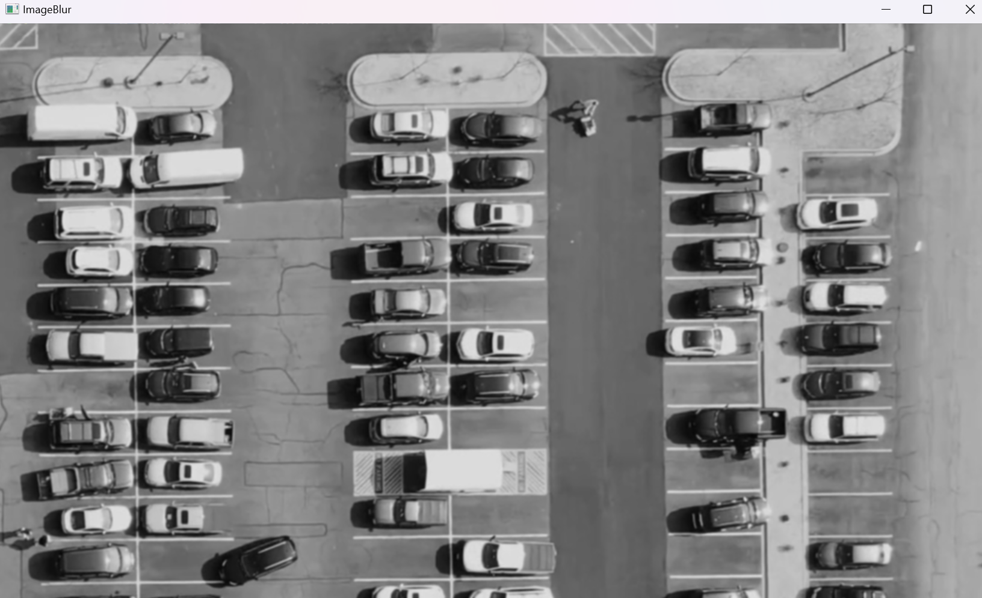

Fig 5:applying gaussian blur

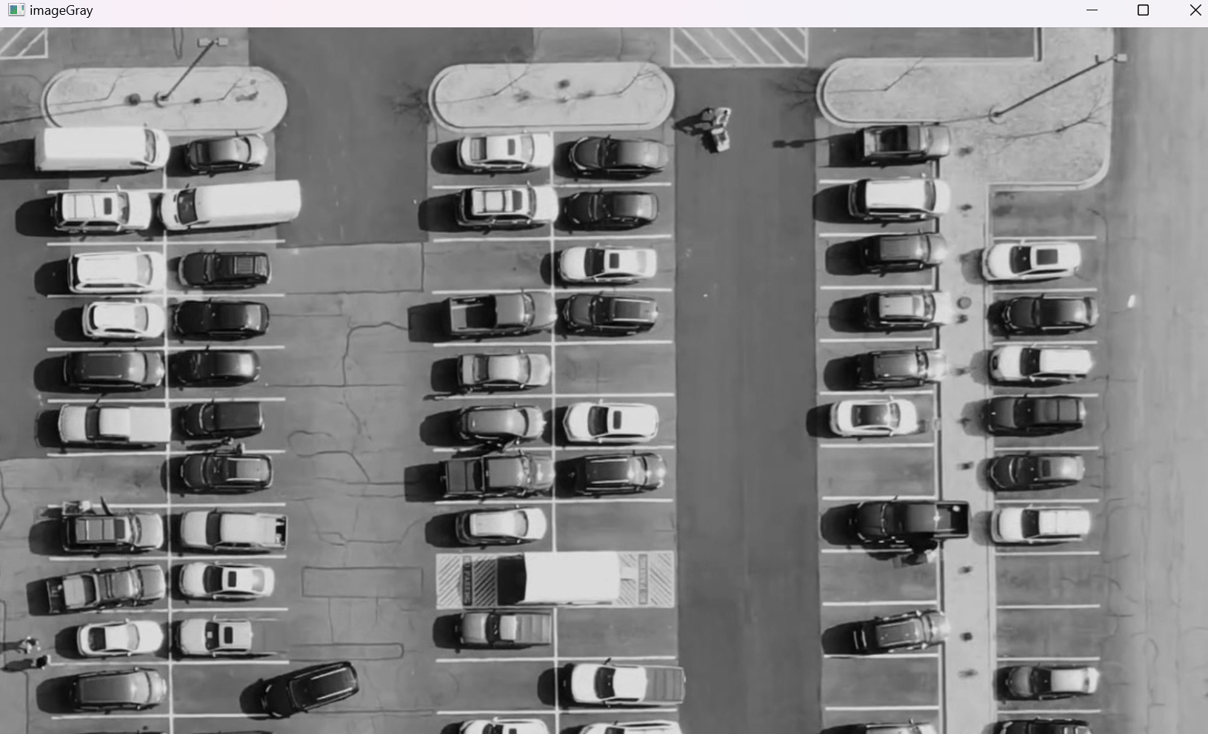

Fig 6: applying adaptive threshold

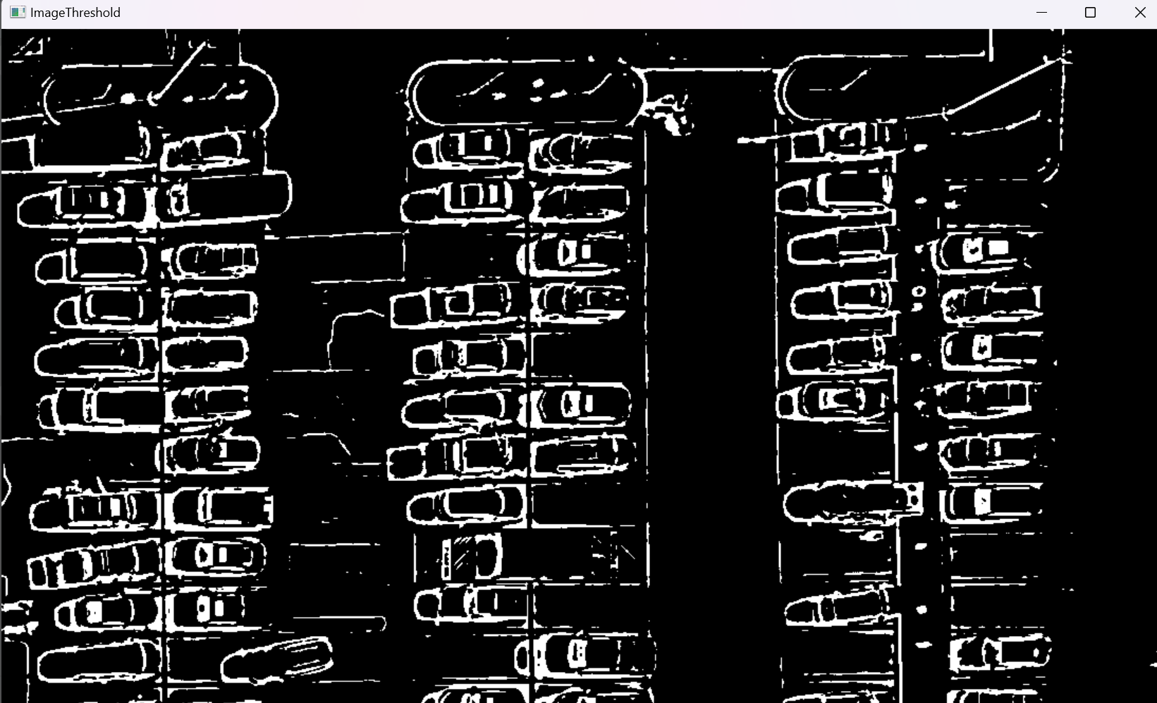

fig 7: applying median blur

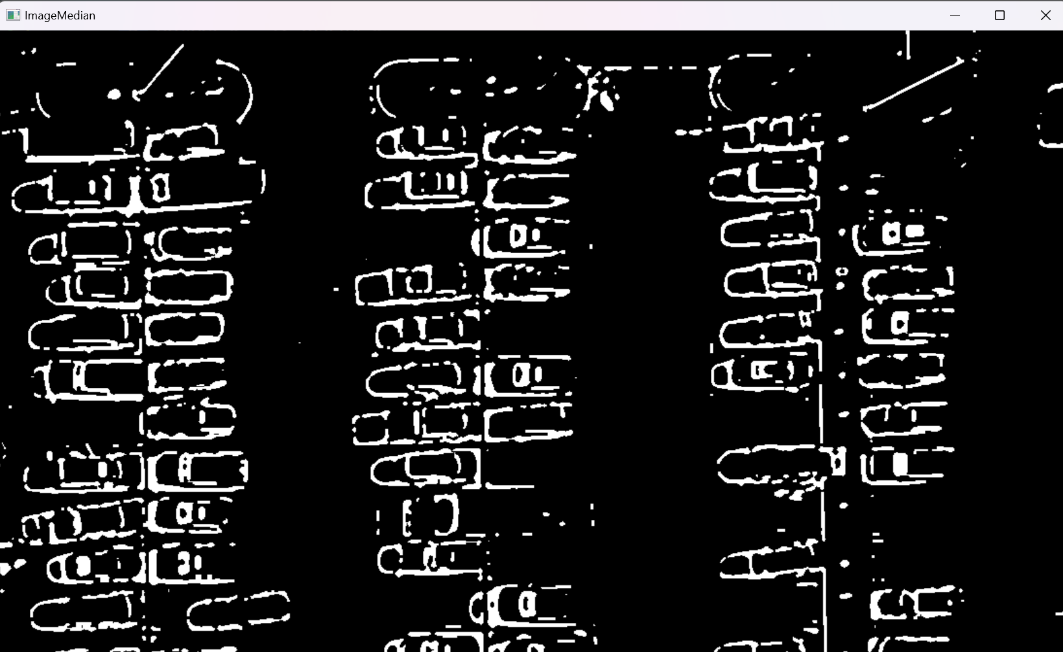

fig 8: final output

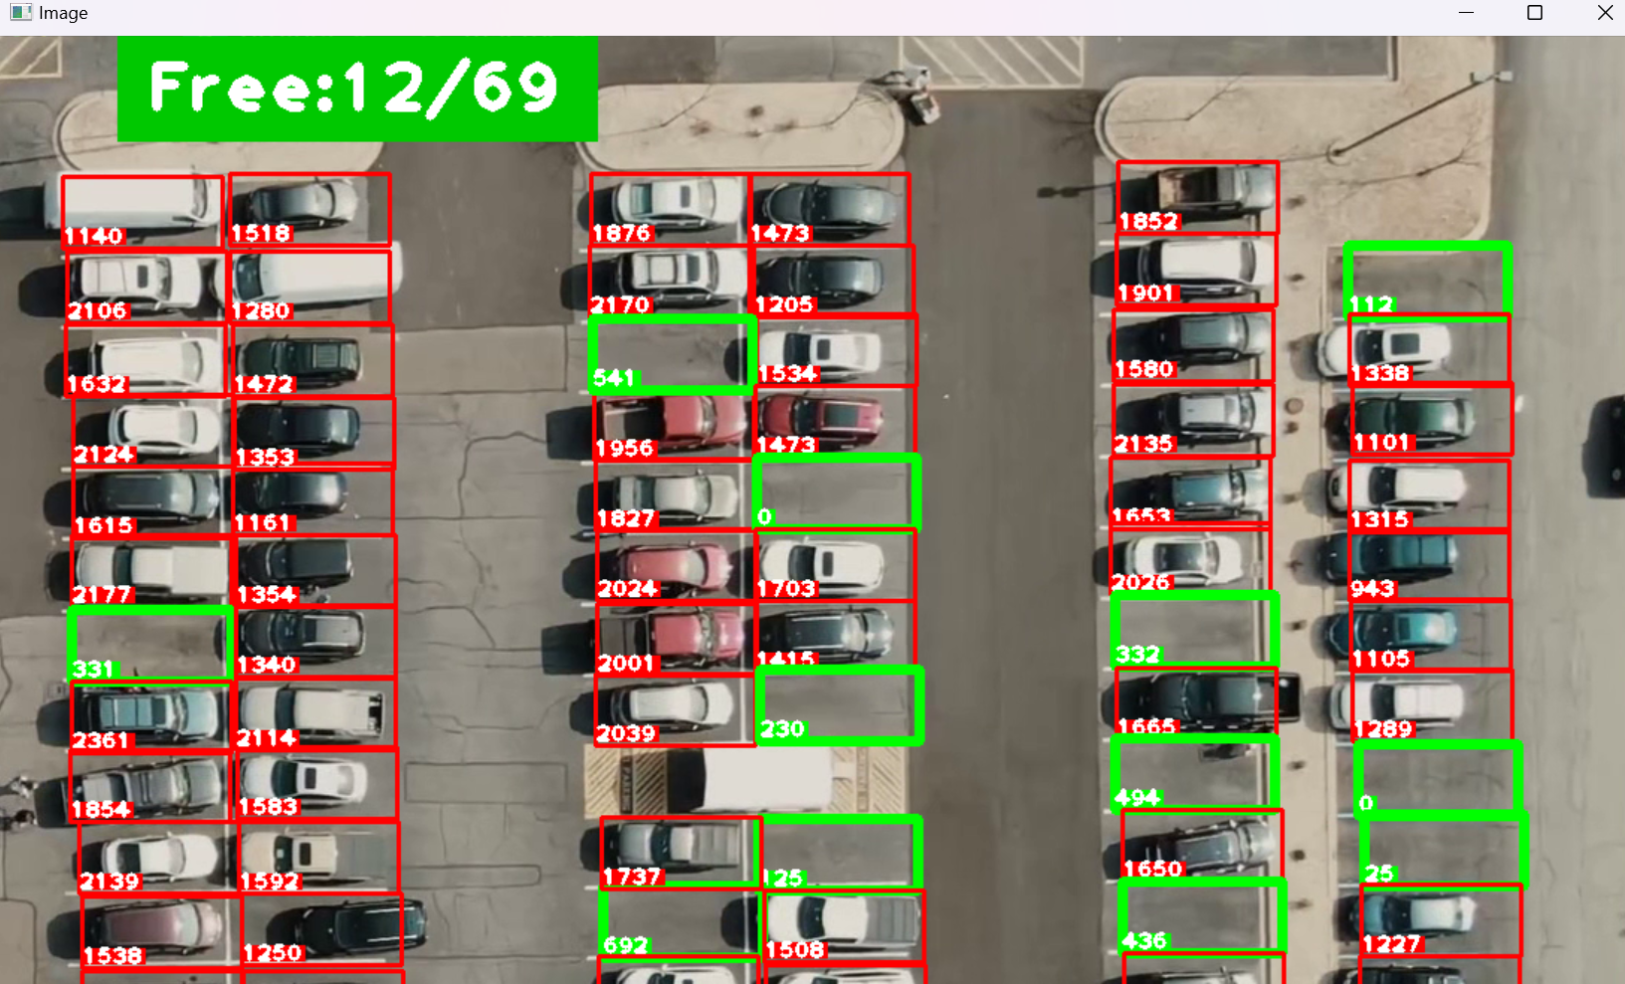

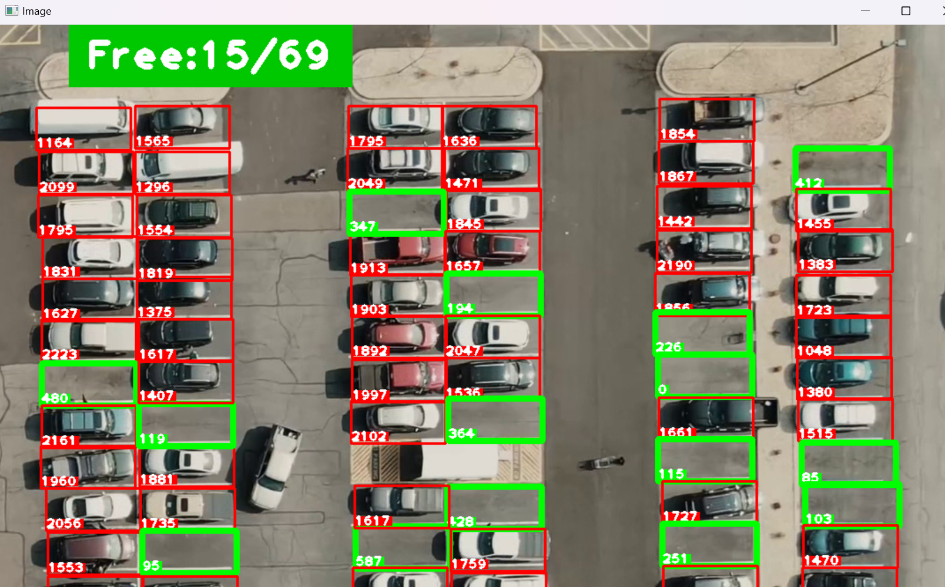

**REFERENCES**

* **VIDEO REFERENCES**: <https://www.youtube.com/watch?v=caKnQlCMIYI>
* **CODE REFERENCE**: <https://www.computervision.zone/lessons/files-and-code-2/>
* **ABOUT:**
  + **OPENCV**: <https://www.geeksforgeeks.org/opencv-overview/>
  + **PICKLE**: <https://www.geeksforgeeks.org/understanding-python-pickling-example/>
  + **NUMPY**: https://www.w3schools.com/python/numpy/numpy_intro.asp